SALES AND PURCHASE AGREEMENT
( Aviation Fuel Jet A1 ) Non-Embargo - Kazakhstan ORIGIN (121 months contract)

Date: Aug 21, 2025, REF: ŞTKWRNFTHUU29/JTC0HYGGYTG

CONTRACT NO  TRANSACTION CODE | ŞTKWRNFTHUU29/JTC0HYGGYTG  ASNNFT/FOB/057 JET A1/ 9781/ 064/ 26 FOB ASWP NON-EMBARGO - Origin  Aviation Fuel Jet A1  APPENDIX -1  US$70 (121MONTHS FIX RATE UNCHANGED)  NCNDA/IMFPA  Aug 21, 2025  Aug 21, 2035
ORIGIN:
PRODUCT
TOTAL QUANTITY
FOB PRICE (GLN)
PRICE BASIS FEES
DATE OF ISSUE
EXPIRATION DATE

THIS AGREEMENT, MADE AS OF THE 10ND DAY OF Aug 21, 2025, BY AND

BETWEEN: THE SELLER

COMPANY NAME:
REGISTRATION NO.
REGISTRATION DATE
REGISTRATION COUNTRY
COMPANY ADDRESS
TAX NO.
LEGAL REPRESENTATIVE
DESIGNATION
PASSPORT NO.
NATIONALITY
E-MAIL
WEBSITE
MOBILE NUMBER

Herein referred to as the “SELLER”

THE BUYER

MEMBER OF and Co Buyer :
SIERRATURK HOLDING GROUP AFRİCA PTY LTD. PO BOX 3931 TYGERVALLEY CAPE TOWN WESTERN CAPE 7536
Telephone: Off +90 532 287 52 35
Registration Number: 2025 / 2025 / 311055 / 07 TAX Number : 9169731289
Website: www.sierraturkgroup.com

COMPANY NAME: | SIERRATURKS GLOBAL TRADING VE İNŞAAT SANAYİ TİCARET LİMİTED ŞİRKETİ
REGISTRATION NO. | 291569-5
REGISTRATION DATE | 02 February 2021
REGISTRATION COUNTRY | TURKEY
COMPANY ADDRESS | 19 Mayıs Mahallesi, Halaskargazi Caddesi. No: 226 /24, ÇIFTKURT PLAZA, KAT: 7, PK 34363 Şişli, Istanbul, Türkiye
TAX NO. & COUNTRY | 7691860676 - Mecidiyeköy VD.
LEGAL REPRESENTATIVE | Dr. Şeref TUFAN
DESIGNATION | CEO and Business Owner
PASSPORT NO. | U14452979 (TR)
NATIONALITY | TURKIYE
E-MAIL | seref@sierraturksglobaltrading.com.tr
WEBSITE | www.sierraturksglobaltrading.com.tr
MOBILE NUMBER | + 90 532 287 52 35

Herein referred to as the BUYER” BROKER:
Designation: CEO/Director (Hereinafter referred to as "The Buyer Broker")

WHEREAS SIERRATURKS GLOBAL TRADING VE İNŞAAT SANAYİ TİCARET LİMİTED ŞİRKETİ, THE SELLERS,
irrevocably confirms and warrants with full personal and corporate responsibility, and full legal authority, that we are ready, willing and able to enter this Sales and Purchase contractual agreement with (REFİNERY NAME), under penalty of perjury, to sell and deliver the commodity as stipulated in this agreement, good, clean, unencumbered, free of liens and of non-criminal origin.

WHEREAS (REFİNERY NAME) , THE BUYER, hereby confirm with full responsibility and authority that we are ready, willing and able to enter sales and purchase contractual agreement for Aviation Fuel Jet A1 With rolls and extensions, according to the following specifications, terms and conditions under the agreed procedure as mentioned herein.

WHEREAS the parties mutually desire to execute this Contract which shall be bound upon and in accordance with the jurisdictional law of the negotiated and fully executed contract

WHEREAS, the Parties mutually desire to execute this Contract, which shall be binding upon and inure to the benefit of the Parties, their legal representatives, Successors and Assignees, in accordance with the

jurisdictional law of the negotiated and fully executed Contract with terms and provisions hereunder agreed upon.

WHEREAS SELLER and BUYER, under full corporate or trust authority and responsibility respectively represent to each other on the date hereof that the Seller is the lawful owner of the Commodity, in the quantity and quality hereunder specified, and the Buyer has the full capability to purchase the said Commodity.

LANGUAGE AND INTERPRETATION

In this Agreement, unless the context otherwise requires:
- The whole text of the present Contract, as well as the documents derived from it, including those in the Annexes, have been written in English, as the First International and being deemed authentic, but for legal purposes, Non-English Legal Terms may be used.
- The grammatical errors, typing errors if any type shall not be considered as contradictions.
- The entire text of this contract cannot be interpreted to limit or change the subject matter of this contract.
- The headings and underlining in this Agreement are for convenience only and shall not be deemed to be part hereof or be taken into consideration in the interpretation or construction of this Agreement.
- Words importing the singular includes the plural and vice versa.
- Words importing a gender includes any gender.
- An expression importing a natural person includes any company, partnership, joint venture, association, corporation or other body corporate and any governmental agency.
- A reference to any statute, regulation, proclamation, ordinance or by-law includes all statutes, regulations, proclamations, ordinances or by-laws amending, consolidating or replacing them, and a reference to a statute includes all regulations, proclamations, ordinances and by-laws issued under that statute.
- A reference to a document includes an amendment or supplement to, or replacement or novation of, that document.
- A reference to a Party to any document includes that Party’s successors and permitted assigns.
- A reference to a time and date concerning the performance of any obligation by a Party is reference to the time and date in Loading Port/Country of origin.
- Any reference to a “day”, “week”, “month” or “year” is a reference to a day, week, month or year in accordance with the Gregorian calendar.
- A “month” is a reference to a period starting on one day in a calendar month and ending on the numerically corresponding day in the next calendar month (and reference to “months” shall be construed accordingly) save that, where any such period would otherwise end on a day which is not a Business Day, it shall end on the next Business Day. If any such period starts on the last Business Day in a calendar month or if there is no numerically corresponding day in the month in which that period ends, that period shall end on the last day in that later month, save as aforesaid.

- Any express statement of a right of a Party under this Agreement is without prejudice to any other right of that Party expressly stated in this Agreement or arising at law.
- No rule of construction shall apply to the detriment of any Party because of that Party having control and/or was responsible for the preparation of this Agreement or any part thereof; and
- All schedules and appendices to this Agreement shall form an integral part of this Agreement.

TERMS AND DEFINITIONS

WHEREAS the parties mutually agree to refer to the General Terms and Definitions, as set out by the INCOTERMS Edition 2010 with latest amendments, having the following terminology fully understood and accepted:

US METRIC TONS
Is the unit of volume measured at temperature of 60 degrees Fahrenheit and equal to 42 US /MT

MT - BBL - GALLONS
A measure of weight equivalent to one-thousand-kilogram mass (1.000 kg) or one thousand one hundred-and eighty-liters volume (1,180 liters).

COMMODITY
Is referred to as being " Aviation Fuel Jet A1 " NON-EMBARGO, ORIGIN as per ANNEX “A”, may elsewhere in this agreement also be referred to as “Product” which Specifications are detailed in the ANNEX “A”, which is an integral part of the Contract.

ORIGIN:
DAY: BANKING DAY: MONTH:
CALENDAR: QUARTER: ASTM
Kuwait / Kazakhstan / Qatar / Oman / Turkmenistan / Poland / Philippine (Non- Russian) African / Asian
MEANS A CALENDAR DAY, UNLESS DIFFERENTLY SPECIFIED.
MEANS ANY DAY BANKS ARE OPEN FOR BUSINESS IN THE UNITED STATES. MEANS A GREGORIAN CALENDAR MONTH.
PERIOD OF THREE (3) CONSECUTIVE MONTHS COMMENCING ON
THE 1ST JANUARY 1ST APRIL; 1ST JULY 1ST SEPTEMBER; 1ST OCTOBER1ST NOVEMBER, OR 1ST OF DECEMBER.

American Society for Testing and Materials (“ASTM”) is the institute internationally recognized that approves all standards, tests and procedures used in the Oil Industry and to be referred in this agreement to the latest revised edition with amendments in force to date.

OUT-TURN
the quantity and quality of the product ascertained by the international Independent Laboratory at the loading port, according to the ASTM procedures, on completion of the loading operations. The so determined out-turned quantity and quality is the basis on which the amount will be computed for the payment of the product effectively delivered to the Buyer.

BILL OF LADING
is the official document, issued at the load port after completion of the loading operations, stating the ship’s loaded quantity expressed in BARRELS (BBL) expressed as per the above definitions. This document must be signed in original by the Ship Master and made out in accordance with the instruction hereinafter specified in this agreement.

CIF / FOB
Cost Insurance & Freight; picked up at Loading Ports, AKTAU / BATUMI/TURKAMANISTAN/NETHERLAND

DISCHARGE PORT
ASWP

Platt’s

Platt’s Below International market scan quotation for Aviation Fuel Jet A1 for European Platt’s is the internationally recognized and accepted organization, which publishes Platt’s European Market Scan official market scans. Market disruption means that:
- Platt’s fails to announce or publish information necessary for determining the price index.
- The failure of trading to commence or permanent discontinuation or material suspension of trading in the relevant commodity or market acting as the price index.
- The temporary or permanent or discontinuance or unavailability of the price index.
- The temporary or permanent closing of any exchange acting as the price index; or
- Material changes in the formula for or the method of determining the price index.

BUYER’S SIGNATURE | SELLER’S SIGNATURE

Surveyor
SGS-Societe-Generale de surveillance, or any internationally recognized independent laboratory.

CLAUSE 1 - SCOPE OF THE CONTRACT
  - The BUYER agreed to purchase on a contract basis, which has agreed to purchase with a total of 24.000.000.000 BBL. amount of 200,000,000 BBL. - Aviation Fuel Jet A1 -/+5% in a
total of 120 months.
  - The 120 months shipment amounts to $ 1.680.000.000.000 USD

CLAUSE 2 - COMMENCEMENT OF THIS AGREEMENT

2.1 The Parties hereby agree that this Agreement shall become effective on the Effective Date and shall continue to be valid for 121 MONTHS in accordance with the terms and conditions expressly
stated in this agreement.

CLAUSE 3 – COMMODITY

3.1 Aviation Fuel Jet A1, as per ANNEX “1”, and having the contractual minimum
guaranteed specifications as per the non-embargo “GOST” official standard herewith attached as an integral part of this contract.

CLAUSE 4 – QUANTITY

4.1 The total contractual quantity of the commodity sold and purchased under this contract is
$ 1.681.540.000.000 USD with an immediate trial order of 24.022.000.000 BBL. +/-5%

CLAUSE 5 – DELIVERY

  - Delivery Terms: 1 months x 22,000,000 BBL + 120 months x 200,000,000 BBL. Aviation Fuel Jet A1- +5% tolerance, Initial trial order origin NON-EMBARGO, Contract FOB ASWP and any other ports.

  - The date of cargo assessment, as reported in the Bill of Lading, is considered as the date of Purchase /delivery.
  - First ship - minimum amount of 200,000,000 BBL. Delivery date is the date of Languorous.
The seller will give the buyer the unlimited, unlimited and excuse tank pair, terminal access permission. 5 -day invoice payment for deposit tanks will be paid to the seller on the same date as the fuel invoice. .The recipient will not pay for access to tanks.

CLAUSE 6 -TERMS

6.1 Contract purchase 24.022.000.000 BBL. -/+5 % tolerance, FOB ASWP under INCOTERM 2020 with latest edition.

CLAUSE 7 – PRICE AND PRICE RULES

The Buyer and the Seller have agreed to the following Price Terms and specifications:

  - Price is based on FOB
  - Should the parties be willing to pursue the delivery on CIF basis after 60 months of the commencement of this contract, an ADDENDUM can be added to this contract with to states the prices and rules of sales.
  - The contract shall be valid for 121 MONTH and cannot be modified, broken or terminated by either party.
  - The buyer undertakes to pay 90% of the agreed upon payment when the tanks are 90% full and the other 10% are transferred when the tanks are 100% full.
  - The seller undertakes to deliver the same product with the same specifications and via the same ports unchanged for 121 MONTHS
  - To ensure smooth cooperation between the parties, the buyer’s technical team should be allowed to visit the site and inspect the tanks with prior coordination with the seller team after full processing and payment of the previous order.
  - The price shall be fixed unchanged/unmodified/unreviewed in USD during the first 121 MONTHS. 7.8
The price for the following 121 MONTH shall be increased ONLY by US$ %5+ Aviation Fuel Jet
A1 shall be fixed/unchanged/unmodified/unreviewed for the following 121 Months
7.9 The seller undertakes to undertake the cost of the total injection agreement, and the buyer pays for tanks after injecting the product receiver's tanks.

CLAUSE 8 – PAYMENT

With Clause 7 into consideration, the following can be implemented:

8.1 The seller shall undertake the payment for the extension of the terminals and tanks, and the

8.2

8.3
unlimited, unlimited and excuse tank pair will allow the buyer a terminal access permission. It will then issue an original expense invoice to pay these costs on the same date as the fuel invoice to the buyer. This cost will not be more than a 2-day tank storage invoice amount. TSR and these costs will be paid to the seller at the same time with the fuel invoice.
Total payment deposit to cover total amount in U.S. Dollars corresponding to the Purchase of 605.000.000.000 GAL. Aviation Fuel Jet A1 - is to be paid after SGS inspection by the buyer at discharge port.
All banking charges of all kinds shall be paid the parties in their own bank.

CLAUSE 9 - PROCEDURES

(FOB – PROCEDURE)

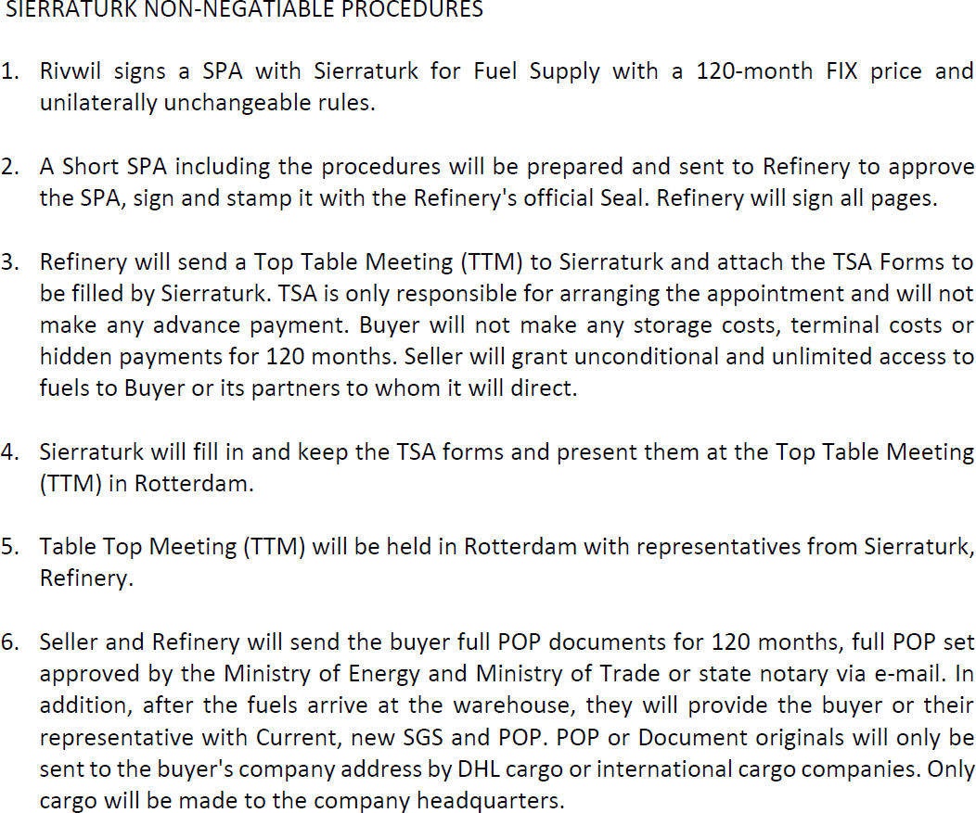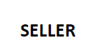

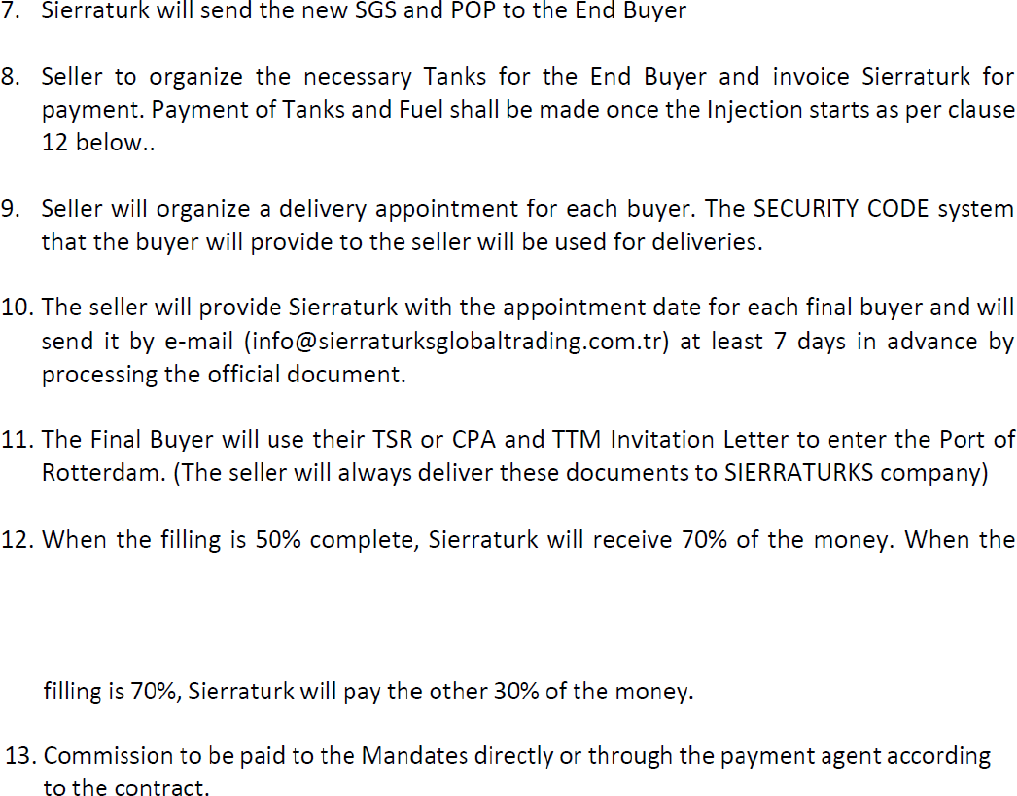

*** Full pop and pop documents will only be issued on behalf of the buyer company that appears to be a customer in the contract. Different customer names will not be valid in the documents. In all of the documents, the state shall be approved by the notary signatures and the Ministry of Energy. The seller will send these documents approved. ***

BUYER’S SIGNATURE | SELLER’S SIGNATURE

CLAUSE 10 - INSPECTION - QUANTITY / QUALITY DETERMINATION

The quality and the weight of the products shall be ascertained and certified by SGS at Seller’s cost in the loading port.

  - Seller shall hire an internationally recognized first class independent inspection/surveying
company, approved by Buyer and approved by Government governing the Port of Loading, if required, to inspect the ordered allocation being loaded onto Vessels at the Port of Loading, and Buyer shall appoint an internationally recognized first class independent international inspection/surveying company after title transfer and physical possession to assess and certify the quality and quantity of the stored product/cargo according to the provisions herein stated.

  - Quantity and quality assessments, conducted by the appointed International Survey Company, shall be in accordance with methods and procedures usually used in the oil industry practice, and however, always, shall strictly comply with the revised ASTM International Standards and Procedures applicable at the date of inspection.
  - For converting volumes, from observed to standard temperature, and volume measures to weight, ASTM tables, the latest revised edition, must be used.
  - Results of the Surveyor’s assessment at the unloading terminal, absent fraud or manifest error, shall be final and binding on the Parties.
  - The quantity and quality of each shipment of oil shall be assessed by the Surveyor at the loading port on completion of each loading operation based on shore and ship figures, or as otherwise stipulated by Clause 3 of this contract. This assessed quantity will be used for computing the amount to be paid to the Seller, applying the price as per clause 6.1 of this contract. The formula for computing the value of each single batch is as follows:
BV=P x Q Where:
BV: denotes the value of the full contract batch
Q: denotes the quantity in Barrels of the single batch
P: denotes the price as per clause 6.1 above
  - In the event of there being an inaccuracy with devices used to measure the Quantity and Quality received at the loading port (failure of flow meters, meter banks and/or other devices) then, manual shore tank measurement shall be applied. Should the Surveyor’s report that the above is the case, and in his opinion the shore tanks are ship figures: TCV (Total Calculated Volume), applied a valid V.E.F. (Vessel Experience Factor), shall be used to compute the delivered quantity of the current batch and the allowable loss on every shipment caused by the above said case is not more than 0.5% from the total quantity of every shipment.
  - At its own expense, each Party to this contract may have a representative present to witness all measurements and tests while Party holds title to the goods

Arbitration Samples:

  - During loading of the tanker arbitration samples are to be taken from the auto sampler or flow meter. Sampling should be performed according to standard procedures currently accepted at the port of loading. Samples thus taken shall be thoroughly mixed, put into labeled bottles and sealed. Similarly, for pipelines, samples shall be taken before loaded into the pipelines, and surveyor/inspector shall take samples once product is being loaded into Buyer’s storage/vessel.
  - One part of samples filled into properly labeled bottles and sealed by Seller, or its appointed representative is to be placed on board the tanker under the care of the captain for delivery to the Buyer or its appointed representative at the unloading terminal.
  - The samples taken shall be considered as the only samples for arbitration. If loading was made under the observance of the Surveyor, samples taken by the Surveyor shall be considered as arbitration samples.
  - Both parties shall keep these samples for the duration of this Contract, and, in case of claims, until the moment of settlement or complete resolution.

BUYER’S SIGNATURE | SELLER’S SIGNATURE

CLAUSE 11 FORCE MAJEURE

  - Neither Seller nor Buyer shall be liable for failure to perform, any or all the provisions set out in this contract, if the performance has been delayed, hindered or prevented by reason of any
cause that may be, even though the affected party exercised due diligence.
  - Where such failure or delay is caused by force major being any event, occurred by circumstance reasonably beyond the control of that party, including without prejudice to the generality of the foregoing failure or delay caused by or resulting from Acts of God, strikes, fire, floods, wars (whether declared /undeclared), riots, destruction of the materials, delays of carriers due to break down or adverse weather, perils of embargoes, accidents, restrictions imposed on by any Governmental authority (including allocations, requisitions, quotas and price controls).
  - The International Chamber of Commerce rules and regulations shall apply (ICC Edition 2000 with the latest amendments).
  - Either Party, in the occurrence of a Force Majeure case, shall inform in written the other Party describing the nature and the estimated period of such occurrence. Should such a case of Force Majeure persist for more than thirty (30) days from the notification date, then Seller and Buyer shall, upon mutual decision suspend or cancel the present agreement ceasing in such way their responsibilities, rights and obligations without any compensation for damages, if any.
  - The certificate issued in original by the competent recognized Authority shall be deemed as sufficient proof for the claimed Force Majeure and its duration.

CLAUSE 12 – INDEMNITY

12.1 Each party (the “Indemnifying Party”) shall indemnify, defend and hold harmless the other party
(the “Indemnified Party”), its affiliates, and its respective officers, directors, employees, agents, and representatives from and against any and all claims, damages, losses, liabilities, judgments, settlements, costs and expenses (including reasonable attorney’s fees) arising from or in connection with any breach of this agreement by the Indemnifying Party or its representatives, except to the extent that such claims, damages, losses, liabilities, judgments, settlements, costs and expenses are caused by the negligence or intentional misconduct of the Indemnified Party. The Indemnified Party shall promptly notify the Indemnifying Party of any such claim and reasonably cooperate with the Indemnifying Party in defense of such claims at the Indemnifying Party’s expense.

CLAUSE 13 – PENALTY

  - Buyer has the option to receive payment from the Seller, in the event Seller does not perform as per this contract. The maximum claim of 2% of the total value of the cargo will be collected by the Buyer in case the Seller does not provide verifiable documents to the Buyer as full POP.
  - The seller has the right to demand 2% penalty if Buyer fails to send acceptable 2days tank extension payment confirmation. Buyer must pay 2% of total contract value in that case in 3 banking days. All payments will be made at the same time as the payment date of the fuel invoice.
  - BREACH: If any party breaches the obligations given to it by this agreement, it shall be entitled without prejudice to the other parties. It may consider such failure as a breach of this contract or unilaterally suspend its obligations.
  - In both cases, until the malfunction is corrected, it may compensate for the losses and damage caused by the non- compliance in question. Causative. In case of breach of contract, a penalty of USD TOTAL CONTRACT PRICE will be imposed on both parties. Payment was not made, and the order was not delivered.

CLAUSE 14 – INSURANCE

14.1 The Seller’s Product is covered under Seller’s Insurance Policy, which covers all risks of loss or damage to said cargo, including war, hijacking, explosion etc. from the time the cargo has passed the refinery’s pipeline center until arrival at the Discharge (Loading) Port, and covers all product in Seller’s storage tanks, refineries, and pipeline transportation.

CLAUSE 15 – CLAIMS

  - Any claims that either party may have, due to an occurrence, must be submitted in writing to the other party within a period of 8 (eight) days from the date of that occurrence.
  - Ianthe event that the quality of any one of the batches fails to comply with the contractual specifications, then the Buyer shall have the option to accept the said batch at a lower price being negotiated and accepted by the Buyer.
  - If within eight (8) calendar days from date of Purchase, if the Buyer fails to inform the Seller confirming the non- compliance, then the commodity is considered accepted by the Buyer, and the Seller will accept no claim.

CLAUSE 16 - TAXES OBLIGATIONS AND EXPORTS

  - The Seller shall pay all any taxes, duties, related to the performance of this contract and collected from Refinery up to Point of Delivery FOB.
  - The Buyer shall pay all any taxes, duties related to the performance of this contract and Collected

from Point of Delivery FOB up to discharging port.
  - Seller or/and Buyer has the rights to assign their obligations / in delivery, payment / to another/third party but it must be advised to their original party to undertake.

BUYER’S SIGNATURE SELLER’S SIGNATURE

CLAUSE 17 - LIABILITY EXEMPTIONS DUE TO FORCE MAJEURE:

  - Neither Seller nor Buyer shall be liable for failure to perform, any or all the provisions set out in this contract, if the performance has been delayed, hindered or prevented by reason of any cause that may be, even though the affected party exercised due diligence.
  - Where such failure or delay is cause by Force Majeure being any event, occurred by circumstance reasonably beyond the control of that party, including without prejudice to the generality of the foregoing failure or delay caused by or resulting from Acts of God, strikes, fire, floods, wars,(whether declared / undeclared), riots, destruction of the materials, delays or carriers due to break down or adverse weather, perils of embargoes, accidents, restrictions imposed on by any Governmental Authority (including allocations, Requisitions, quotas and price controls)
  - The certificate issued in the original language by the competent recognized authority shall be deemed as-proof for the claim force majored and this duration.

CLAUSE 18 - APPLICABLE LAW

18.1 The Swiss Law shall govern all matters relating to the validity, interpretation or the Performance of
this contract. The contract is for 121 months, and the prices do not change, the terms of the contract do not change, and the agreement cannot be terminated unilaterally. If one of the parties gives up or terminates the contract, the other party will pay compensation up to the total amount of the contract. The parties have accepted this.

CLAUSE 19 - ARBITRATION

  - All disputes arising in connection with the present contract shall be settled in an amicable way first. Should no agreement be reached by the parties, then the case shall be brought for final settlement under the rules of Conciliation and Arbitration of the International Chamber of Commerce in Bern by one or more arbitrators in accordance with the said Rules.
  - Each Party shall appoint one arbitrator, nothing in the agreement shall be construed to prevent any

Court having jurisdiction from issuing injunctions, attachment orders or orders for other similar relief in aid of any arbitration commenced (or to be commenced) pursuant to the Section. Judgment upon the award rendered by the Arbitrator(s) could be entered into the Court having jurisdiction hereof.
  - Neither party shall fail to comply in a timely way with the obligations of this party to be performed in pursuance to this contract although a dispute has arisen and proceeded to arbitration.
  - Findings as assessed by the designated third arbitrator, without any possibility of recourse, will be final and binding on both parties.

CLAUSE 20 - SPECIAL CONDITIONS

20.1 Each of the Parties warrants that it has exerted and shall continue to exert its reasonable

commercial efforts to avoid any action, which might be detrimental to the other Party’s interest in the negotiation, execution and performance of this Contract.

CLAUSE 21 - LAY CAN
  - Buyer shall notify Seller of the delivery schedule over the contract period covering the
Aviation Fuel Jet A1- specifying the lay cans at designated load port(s) promptly. The Seller has designated load terminal(s) shall officially conform and direct to the Buyer, the delivery schedule and related lay cans.
  - Lay cans at Seller-designated loading port(s) are to be fixed with 3(Three) days’ range and in accordance with the delivery schedule.
BUYER’S SIGNATURE SELLER’S SIGNATURE

CLAUSE 22 - ASSIGNMENT

21.1 Neither Party may assign this Contract or any of its rights or obligations hereunder without the
prior written consent of the other Party. This Contract shall inure to the benefit of and be binding upon the Parties and their respective successors and permitted assigns.

CLAUSE 23 – GENERAL

  - This Contract contains the entire understanding between the Parties with respect to the transactions contemplated hereby and can only be amended by a written agreement. Any prior agreement, written or verbal is deemed merged herein and shall be superseded by this Contract.
  - This Contract may be executed simultaneously in 2 (Two) or more counterparts, each of which shall be deemed to be an original.
  - The article and other headings in this Contract are for convenience only and shall not be interpreted in any way to limit or change the subject matter of this Contract.
  - All signed appendices, annexes & supplements shall constitute an integral part of this Contract.
  - Time is of the essence with respect to all aspects of each Party’s performance of all obligations under this Contract.
  - Conditions that have not been specified in the present Contract shall be governed by INCOTERMS 2010 and subsequent amendments related to FOB. Basis at Discharge Ports.
  - EDT (Electronic Document Transmission) shall be deemed valid and enforceable in respect of the provision of this Contract. Either Party shall be entitled to request and receive a hard copy of any previously submitted electronically transmitted document.
  - Grammatical mistakes, typing errors, if any, shall not be regarded as contradictions.
  - The verbiage Text of the BG, mutually agreed upon by both parties, shall OVERRIDE any contradictions in this contract and a draft copy of which shall be entered as a Supplementary Schedule as an integral part of this contract.

CLAUSE 24 - LIABILITY AND NON-WAIVER

  - In no event shall Buyer be liable for indirect or consequential damage incurred from the original performance and or quality of the Aviation Fuel Jet A1 - supplied and delivered by the supplier.
  - The failure of either party to insist in any one or more instances upon strict performance of any of the provisions of this Agreement or to take advantage of any of its rights hereunder shall not be
construed as a Waiver or any such provisions or the relinquishments of any such rights, but the same shall continue and remain in full force and effect for the term of this Agreement.

CLAUSE 25 -CONFIDENTIAL, NON-DISCLOSURE AND NON-CIRCUMVENTION

24.1 All parties related to this contract accept and agree to the internationally accepted provisions for non-
circumvention and non-disclosure about all and every one of the parties involved in this Transaction and contract, and any additions, renewals and third-party assignments, with full reciprocation for a period of 10 years of the execution of this contract.

CLAUSE 26 – INTERMEDIARIES AND COMMISSION PAYMENT

  - Seller and Buyer note that the present contract came into existence with the help of intermediates, so commission must be paid. All the Commission will be paid by Seller by a separate contract, which is indispensable part of the main contract acc. to ICC 500,600.
  - Commissions will be paid by the Seller to the individual paymasters.
  - The Master Fee Protection Agreements are an integral part of the Agreement

CLAUSE 27. ENTIRE AGREEMENT

  - This Agreement contains the entire Agreement between the parties with respect to the subject matter hereof and all proposals, negotiations, and representations with reference thereto are merged herein.
  - Any written alterations and appendices to this Agreement shall be valid only when signed by both Parties.
  - All Appendices and Additions duly signed shall be an integral part of this Agreement.
  - No oral representations unless set forth in this Agreement will be binding between the parties of this Agreement.
  - This Agreement has been made in 9(Nine) originals of 5 (Five) pages including 3 (Three) appendices written in English language, where 3 (three) originals are being received by Buyer and 3 (three) originals are being received by Supplier. All originals shall be equally enforceable

BUYER’S SIGNATURE SELLER’S SIGNATURE

*** END OF THIS PAGE ***

CLAUSE 28 – BANKING COORDINATES

IN WITNESS WHEREOF, the parties hereto have caused this Agreement to be executed by their authorized officers or officials as of the day and year hereunder written

BREACH: If any party breaches the obligations given to it by this agreement, it shall be entitled without prejudice to the other parties. It may consider such failure as a breach of this contract or unilaterally suspend its obligations. In both cases, until the malfunction is corrected, it may compensate for the losses and damage caused by the non- compliance in question. Causative. In case of breach of contract, a penalty of USD TOTAL CONTRACT PRICE will be imposed on both parties. Payment was not made, and the order was not delivered

SELLER BANKING DETAILS

THE SELLER
COMPANY
COMPANY REGISTRATION
COMPANY ADDRESS
REPRESENTED BY
DESIGNATION/TITLE
PASSPORT NUMBER
NATIONALITY
DATE SIGNED
INTEGRAL PART OF THE PROCEDURES:

"According to the purchased tender, 20 different groups will arrive every month; 10 of them will come to the ports in the morning, and the other 10 will come in the afternoon. The managers representing these groups will inspect the fuels in the tank farm personally and conduct physical inspections each month. For 120 months, 20 groups will examine the fuels both in the morning and in the afternoon every month for 10 days.

These groups will come to the ports for verification and report the presence of fuels to the relevant ministries of energy and to me. They should not encounter any problems at the port and terminal entrances, nor should they face any hidden payments or expenses. Their only duty is to observe the fuels and submit a verification report.

After this verification is completed, the same groups will organize SGS teams and return to the port for a bottom test. In other words, the first stage is the physical verification of the fuels, and the second stage is to conduct a bottom test on the fuels. They will not incur any extra costs or payments for these two processes. Our technical team should not face any problems during the physical verification and SGS stages. There should be no obstacles, and they should provide unconditional and unlimited access.
The tank farm will be paid after these procedures are completed.

We apologize. We accept your invoice, but we can always make your payments within 5 business days after the test is completed. There should be zero obstacles and zero conditions between the customer and the fuel."

17

SELLER BANKING – COORDINATES

THE SELLER BANKING COORDINATES
BANK NAME
BANK ADDRESS
ACCOUNT NAME
ACCOUNT NO
COMPANY ADDRESS
SWIFT CODE
IBAN NO
BANK OFFICER
BANK OFFICER CONTACTS

BUYER BANKING DETAILS ( Bank information can be changed )

THE BUYER BANKING COORDINATES
BANK NAME | AKBANK TURKIYE
BANK ADDRESS
ACCOUNT NAME | SIERRATURKS GLOBAL TRADING VE İNŞAAT SANAYİ TİCARET LİMİTED ŞİRKETİ
ACCOUNT NO
COMPANY ADDRESS | 19 Mayıs Mahallesi, Halaskargazi Caddesi. No: 200, PK 34363, Şişli /  İstanbul Türkiye
SWIFT CODE | AKBKTRIS
IBAN NO | TR 38 0004 6000 5400 1000 3377 99
BANK OFFICER
BANK OFFICER CONTACTS

Note: Seller and Buyer reserves the right to change banking coordinates with an addendum to reflect the changes.

*** END OF THIS PAGE ***

By signing this contract agreement in the places provided below, the seller and the buyer agree to be bound by provisions hereof.

The present Contract comes into force upon its signing by the Parties and is valid from the date of SELLER’S ENDORSEMENT OF THIS CONTRACT till the moment of complete fulfillment of deliveries and payments which are compulsory for both Parties IN WITNESS WHERE OF, the parties have executed this agreement as and for, Aug 22, 2025; The parties must fulfill the contract, as active financial instrument must to be operative in maximum 5 days from the date of sign and seal

IN WITNESS WHEREOF, the parties hereto have caused this Agreement to be executed by authorized officers or officials as of the day and year hereunder written

SELLER SIGNATURE AND SEAL |  | BUYER SIGNATURE AND SEAL  COMPANY
COMPANY NAME :  NAME  REPRESENTATIVE:  DESIGNATION  Title: PRESIDENT  DATE  Aug 22, 2025 |  | SIERRATURK HOLDING GROUP AFRİCA, trading as SIERRATURKS GLOBAL TRADING VE İNŞAAT SANAYİ TİCARET LİMİTED ŞİRKETİ  NAME  Dr. Şeref TUFAN  DESIGNATION  Title: CEO and Business Owner  DATE  Aug 21, 2025
STAMP & SIGNATURE |  | STAMP & SIGNATURE

THE EXCUTION OF THIS CONTRACT IS SUBJECT TO ELECTRONIC SIGNATURES AND STAMP OF THE RELEVANT PARTIES

CLAUSE 29 - ATTACHMENTS TO CONTRACT

ANNEX “A” – ORIGIN Aviation Fuel Jet A1

BUYER PAYS FOR BUYER-SIDE – SEPARATE IMFPA – LINKED WITH CONTRACT. SELLER PAYS FOR SELLER-SIDE – SEPARATE IMFPA – LINKED WITH CONTRACT.

ANNEX “B” - TENTATIVE SCHEDULE OF LIFTING

Delivery Schedules for the 3650-Day Contract Period shall be pre-Advised and shall be entered herein as a supplementary delivery schedule for ANNEX “C” and shall be an integral part of this contract

In addition to the procedure, "According to the purchased tender, 20 separate groups will come every month; 10 of them will come in the morning and the other 10 in the afternoon. The managers representing these groups will see the fuels in the tanker with their own eyes and perform a physical inspection every month. For 120 months, 20 groups will check the fuels both in the morning and in the afternoon for 10 days each month. The seller or refinery will not impose any difficult processes on the buyer or their representatives regarding the physical viewing and testing of the fuels, nor will they create
any obstacles to entering the tank farm. There will be no challenging factors or conditions between the fuel and the customer."

ANNEXURE ‘A’ TO CONTRACT
CERTIFICATE OF QUALITY GUARANTEED SPECIFICATION

PRODUCTS SPECIFICATION ( Aviation Fuel Jet A1 )
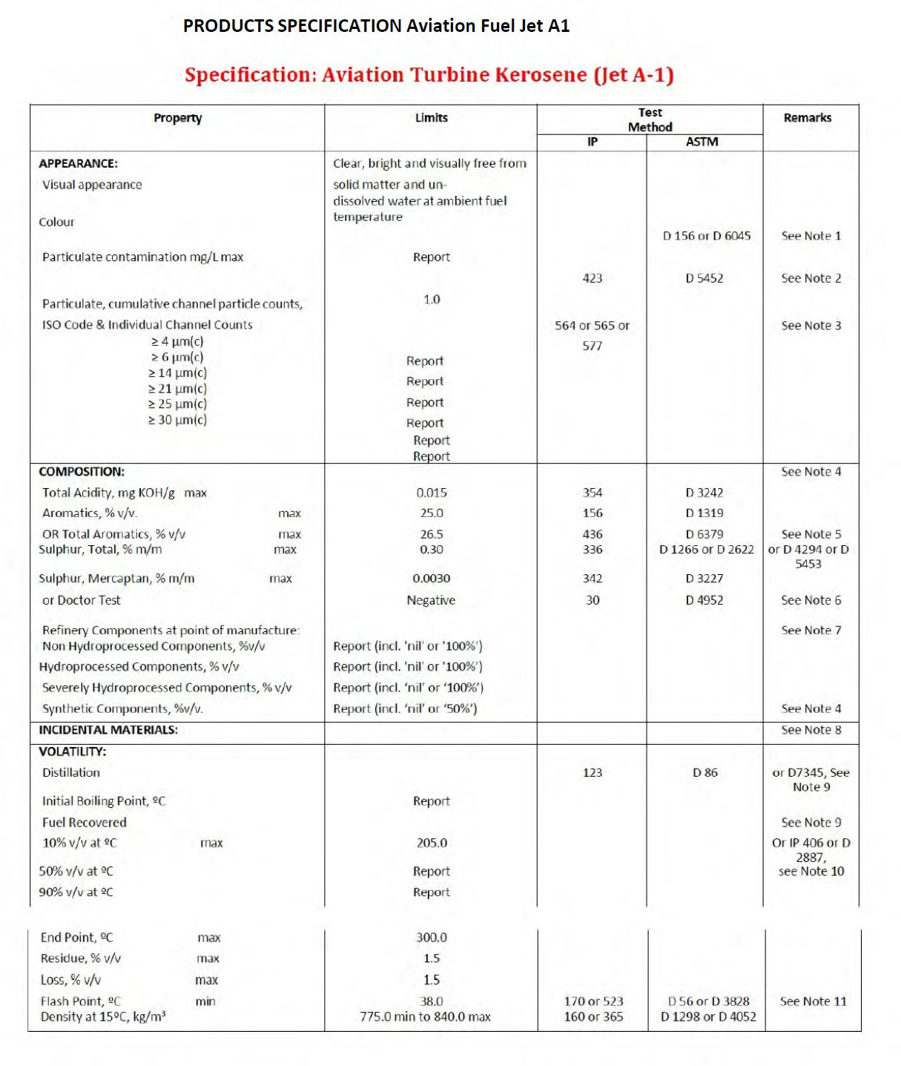

O1 ST YEAR., 4ST SAFE PORT
Each month 24.000.000.000 BBL. product is requested to deliver the MİX Port

ROTTERDAM PORT : 130,000,000 BBL X 120 MONTH
FUJAİRAH PORT: 40,000,000 BBL X 120 MONTH
HOUSTON PORT: 20,000,000 BBL. X 120 MONTH
SİNGAPOURE PORT: 10,000,000 BBL X 120 MONTHS

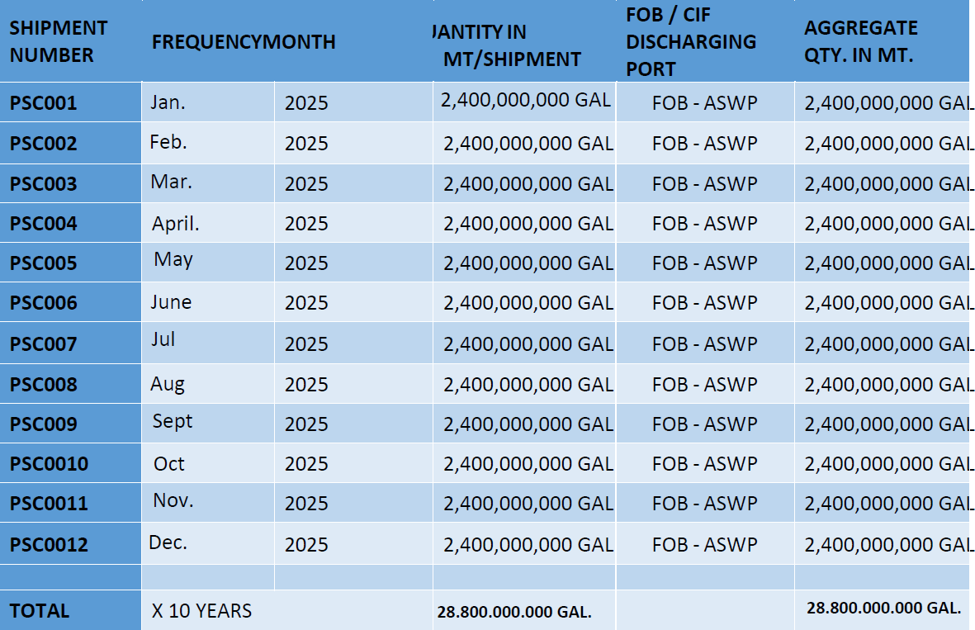

- SELLER GUARANTEES THE SPECS FOR TOTAL SULFUR;
- MASS, TO BE LESS THAN 0.05%.

    - NO CARGO WILL BE ACCEPTED IF THE SGS REPORT STATES MORE THAN 0.05% TOTAL SULFUR

BUYER’S SIGNATURE | SELLER’S SIGNATURE

23

SELLER CERTIFICATES and PASSPORT:

E D T shall be deemed valid and enforceable in respect of any provisions of this Agreement.

As applicable, this Agreement shall be:
- Incorporate U.S. Public Law 106-229, ‘‘Electronic Signatures in Global and National Commerce
Act’’ or such other applicable law conforming to the UNCITRAL Model Law on Electronic Signatures (2001) and;
- ELECTRONIC COMMERCE AGREEMENT (ECE/TRADE/257, Geneva, May 2000) adopted by the United Nations Centre for Trade Facilitation and Electronic Business (UN/CEFACT).
EDT documents shall be subject to European Community Directive No. 95/46/EEC, as applicable. Either Party may request hard copy of any document that has been previously transmitted by electronic means provided however, that any such requests hall in no manner delay the Parties from performingtheir respective obligations and duties under EDT instruments

ELECTRONIC SIGNATURE IS VALID AND ACCEPTED AS HAND SIGNATURE EDT (ELECTRONIC DOCUMENT TRANSMISSIONS)

E D T shall be deemed valid and enforceable in respect of any provisions of this agreement. As applicable, this Agreement shall be:

- Incorporate U.S. Public Law 106-229, "Electronic Signatures in Global and National Commerce Act" or such other applicable law conforming to the UNCITRAL Model Law on Electronic Signatures (2001) and
- ELECTRONIC COMMERCE AGREEMENT (ECE/TRADE/257, Geneva, May 2000) Protocol by the United Nations Centre for Trade Facilitation and Electronic Business (UN/CEFACT).
- EDT documents shall be subject to European Community Directive No. 95/46/EEC, as applicable. Either Party may request hard copy of any document that has been previously transmitted by electronic means provided however, that any such request shall in no manner delay the Parties from performing their respective obligations and duties under EDT instruments.

BUYER’S SIGNATURE | SELLER’S SIGNATURE

BUYER PERSONAL PASSPORT


BUYER CERTIFICATES

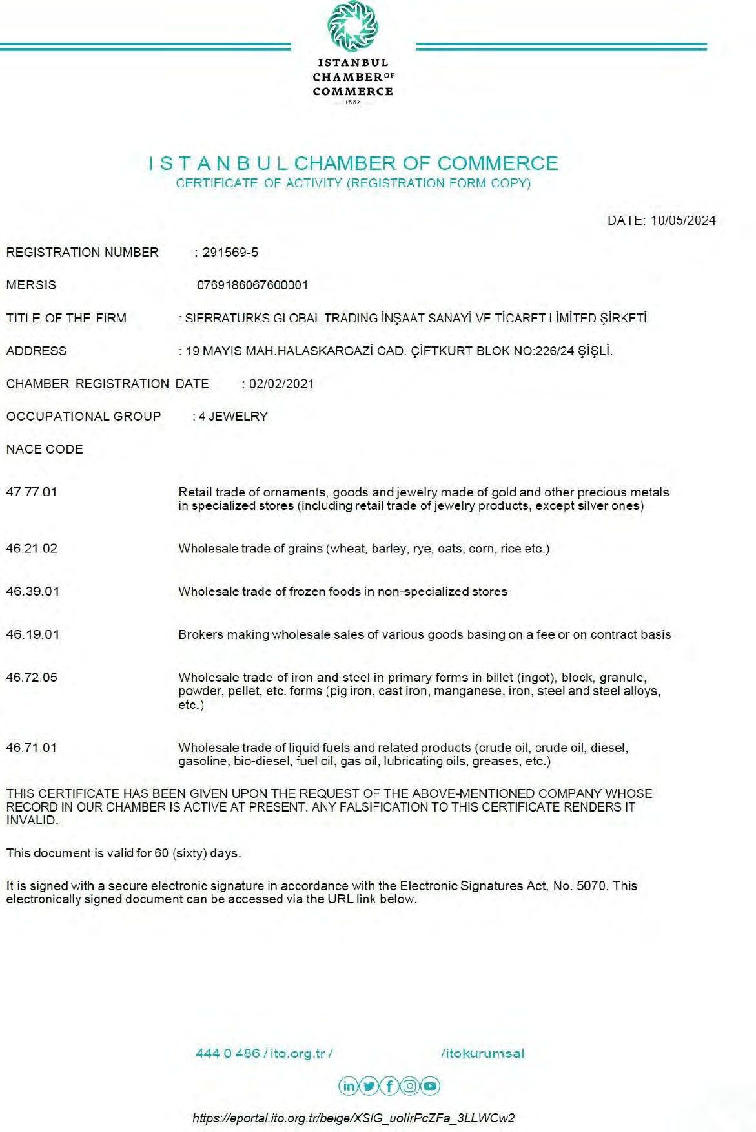

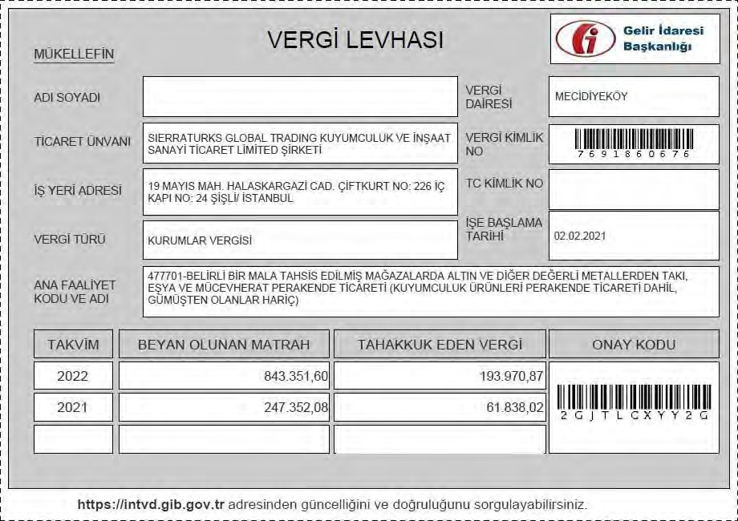
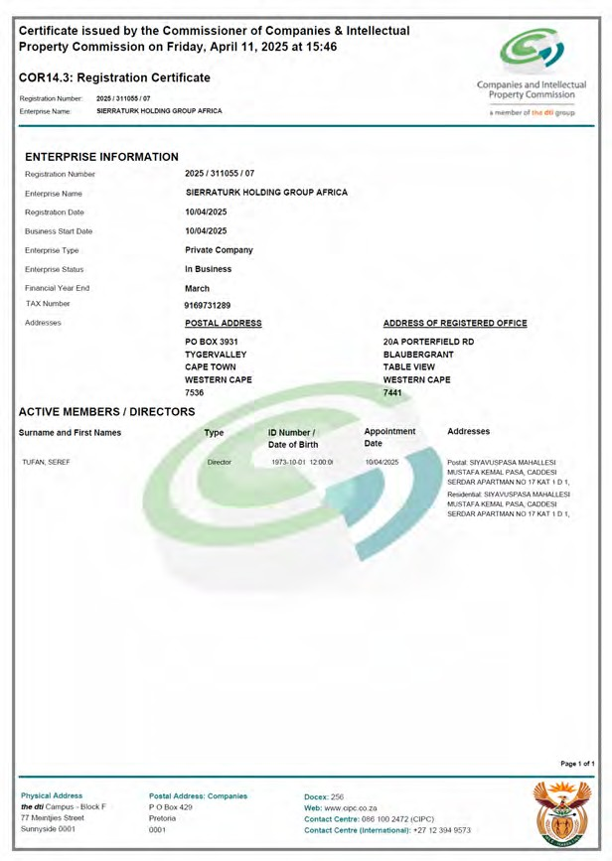
27

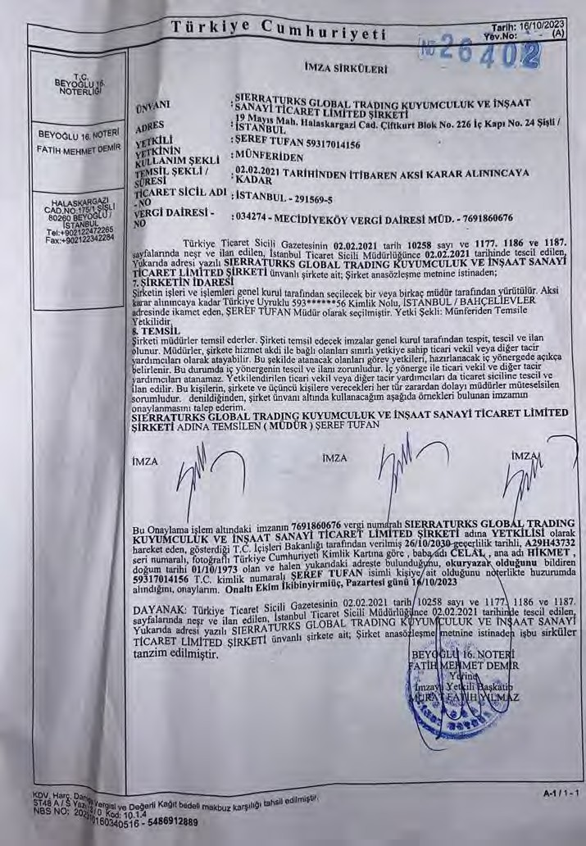

28

