CONTRACT CI № | ŞTKWTGUUUYY14/JTCYBHUII8KJ | COMMERCIAL INVOICE
Date of Issue | 21. 08. 2025 | COMMERCIAL INVOICE
Expiring Date | 31. 08. 2025 | COMMERCIAL INVOICE

TRANSACTING TERMINAL PORT | LOGISTICS COMPANY PRODUCT CURRENTLY  STORED | TRANSACTION CODE | BUYER REFERENCE
ROTTERDAM^{i} |  | ASNNFT/FOB/057 LPG/ 9374/ 064/ 26 | REF: ŞTKWTGUUUYY14/ JTCYBHUII8KJ

QUANTITY | COMMODITY  DESCRIPTION | WEIGHT | UNIT PRICE | TANK NUMBERS | AMOUNT
5,000,000  METRİC TONS | Liquid Petroleum  Gas  - LPG | MT. | $260USD | TBA | $260 USD x 5,000,000 MT.
Product Origin: Kazakhstan |  | Amount: $1.300.000.000 USD  (One billion three hundred million American dollars

 | BUYER DETAILS
Company Name: | SIERRATURKS INTERNATIONAL HOLDING GROUP
Contact name: | Dr. Şeref Tufan
Company Registration: | Reg № 291569-5
Telephone No.: | + 90 850 480 8422
Address: | 226 Halaskargazi Road, District 19-Mayis Mah. Şişli, Istanbul, Türkiye
Email Address: | seref@sierraturksglobaltrading.com.tr

BUYER BANK INFORMATION |  | SELLER BANK INFORMATION
Bank Name | Standard Bank South Africa | Bank Name
Bank Address | Riverside Centre, Main Road, Rondebo 7700, South Africa | Bank Address
Account No. | 071326952 | Account No.
Account Name | SIERRATURK HOLDING GROUP | Account Name
Swift Code | SBZAZAJJ | Swift Code
Bank Officer |  | Bank Officer

PRODUCT SPECIFICATION Liquid Petroleum Gas - LPG

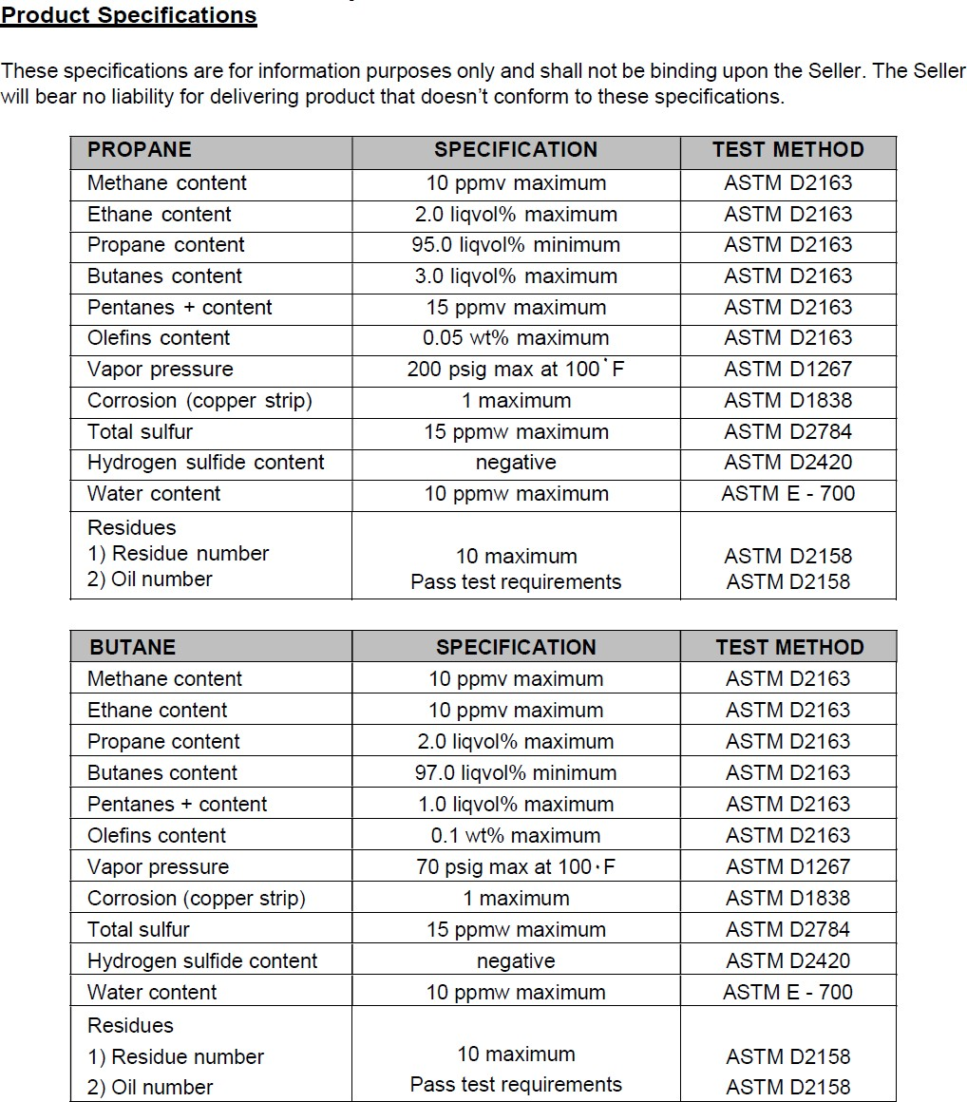

In addition to the procedure, "According to the purchased tender, 20 separate groups will come every month; 10 of them will come in the morning and the other 10 in the afternoon. The managers
representing these groups will see the fuels in the tanker with their own eyes and perform a physical inspection every month. For 120 months, 20 groups will check the fuels both in the morning and in the afternoon for 10 days each month. The seller or refinery will not impose any difficult processes on the
buyer or their representatives regarding the physical viewing and testing of the fuels, nor will they create
any obstacles to entering the tank farm. There will be no challenging factors or conditions between the fuel and the customer."
The product delivery date is no later than Aug 21, 2025. If the seller fails to deliver the products by this date, the buyer will have the right to claim compensation. Similarly, if the buyer does not pay within a maximum of five days after receiving the products, the seller will have the right to claim compensation.

PROCEDURES FOR TRİAL AND ROLL :

- Buyer issues ICPO on receipt of Seller's Soft Offer along with Tank Storage Agreement (TSA) as proof of storage availability.
- Seller issues commercial invoice, for the available quantity in the storage tank to Buyer, Buyer Signs 121 Month SPA and CI and returns to - Seller including copy of NCNDA/IMFPA signed by all buyer groups with commission structures.
- Seller issues the Dip Test Authorization letter for Seller's Tank Farm endorsement along with the following PPOP documents:
  - Product Passport
  - Availability of Product endorsed
  - Guarantee Letter to Supply
- Seller issues Complete DTA attached with fresh SGS Report and Tank Receipt to Buyer, Buyer order SGS to conduct Dip-Test of the product in the Seller's Tank on Buyer expenses submit the full injection report to the Buyer.
- Upon successful Dip Test, sellers inject the fuel into buyer lease Storage Tank and sellers submit the full injection report to the Buyer. Seller makes 5 days free definition.
- Buyer make 100% payment by MT103 TT wire transfer for the total product and Seller pays commission to all intermediaries involved in the transaction within 24 hours after confirmation of the buyer's payment.
- Seller issues draft SPA to buyer to review for R&E monthly deliveries.
- Buyer pays after Dip Test by MT103 Wire Transfer on each monthly quantity. SPA - Valid for 121 months. Cannot be changed, rearranged, canceled, contract terms cannot be revised or abandoned. If one of the parties cannot fulfill the contract terms or cancels the contract, the total fuel bill for 121 months has agreed to pay the contract amount to the other party.
- The subsequent delivery shall commence according to the terms and conditions of the contract.
- Seller pays commissions to all intermediaries as per IMFPA/NCNDA 24 hours after receiving payment from Buyer.
SIGNATORY OF APPROVAL

SELLER STAMP  & SIGNATURE:  CEO | SIERRATURKS INTERNATIONAL HOLDING GROUP.  BUYER STAMP  & SIGNATURE:  DR. ŞEREF TUFAN  CEO / BUSİNESS OWNER

