SALES AND PURCHASE AGREEMENT DİESEL EN 590 10 PPM Non Embargo ORIGIN / 60 MONTH
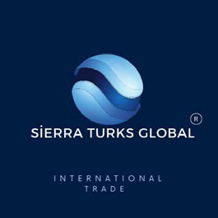

SPA-HEJÇO3UI3

CONTRACT NO : CONTRACT №: KZTRNFTH09832/JTC078165
TRANSACTION CODE : ASNNFT/CIF/DİESEL EN 590 10 PPM - PTC/9783/062/28
: CIF ASWP
DELIVERY TERMS : Kazakhistan / Qatar / Oman / Turkmenistan / Poland ( Non Rusian )
ORIGIN : DİESEL EN 590 10 PPM
PRODUCT : With the first Spot trial order, the first year will be 30.000.000 MT- 360.000.000 MT, the second TOTAL QUANTITY year 360.000.000 MT, and the Three, four, five years 3 x 360.000.000 MT.
: In the first year, US $ 350 per CIF Price MT. will be gross per gross, the second year, US $ 365 per PRICE BASIS CIF Price MT, Three, four, five years, USD $ 385 per CIF Price MT. will be gross. It will not FEES change.
DATE OF ISSUE : 50/50 AS PER NCNDA/IMFPA
EXPIRATION DATE : MAY 15nd, 2024 /: MAY 25th, 2024 (IF NOT SIGNED AND RETURNED BY BUYER)
This Agreement, made as of the 15nd day of MAY 2024 by and between: THE SELLER:
COMPANY NAME
COMPANY ADDRESS
COMPANY REGISTRATION
REPRESENTED BY
NATIONALITY
TITLE
TELEPHONE/FAX
EMAIL
“SELLER”
AND THE BUYER:
COMPANY NAME | SIERRATURKS GLOBAL TRADING VE İNŞAAT SANAYİ TİCARET LİMİTED ŞİRKETİ
COMPANY ADDRESS | 19 MAYIS MAH. HALASKARGAZİ CAD. ÇİFTKURT PLAZA NO.226/24
COMPANY REGISTRATION | 291569-5
REPRESENTED BY | Dr. Şeref TUFAN
NATIONALITY | Turkey
TITLE | Business Owner / Ceo
TELEPHONE/FAX | + 90 532 287 52 35
EMAIL | seref@portvale.com.tr seref@sierraturksglobaltrading.com.tr
Herein referred to as the “BUYER”

Whereas the parties mutually desire to execute this Contract which shall be bound upon and in accordance with the jurisdictional law of the negotiated and fully executed contract.

Buyer Signature : Seller Signature :
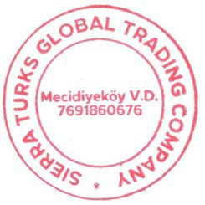

WHEREAS, the Parties mutually desire to execute this Contract, which shall be binding upon and inure to the benefit of the Parties, their legal representatives, Successors and Assignees, in accordance with the jurisdictional law of the negotiated and fully executed Contract with terms and provisions hereunder agreed upon.
WHEREAS, SELLER and BUYER, under full corporate or trust authority and responsibility, respectively represent to each other on the date hereof that the Seller is the lawful owner of the Commodity, in the quantity and quality hereunder specified, and the Buyer has the full capability to purchase the said Commodity.

DEFINITIONS
WHEREAS the parties mutually accept to refer to the General Terms and Definitions, as set out by the INCOTERMS Edition 2010 with latest amendments, having the following terminology fully understood and accepted:

US METRIC TONS
Is the unit of volume measured at temperature of 60 degrees Fahrenheit and equal to 42 US MT.

MT - BBL - GALLONS
A measure of weight equivalent to one-thousand-kilogram mass (1.000 kg) or one thousand one hundred and eighty liters volume (1,180 liters).

Commodity
Is referred to as being DİESEL EN 590 10 PPM NON EMBARGO ORIGIN as per ANNEX “A”, may elsewhere in this agreement also be referred to as “Product” which Specifications are detailed in the ANNEX “A”, which is an integral part of the Contract. ORIGIN : Kazakhistan / Qatar / Oman / Turkmenistan / Poland ( Non Rusian )
DAY : MEANS A CALENDAR DAY, UNLESS DIFFERENTLY SPECIFIED.
BANKING DAY : MEANS ANY DAY BANKS ARE OPEN FOR BUSINESS IN THE UNITED STATES.

MONTH : MEANS A GREGORIAN CALENDAR MONTH.
CALENDAR : PERIOD OF THREE (3) CONSECUTIVE MONTHS COMMENCING ON
QUARTER : THE 1ST JANUARY 1ST APRIL 1ST JULY 1ST SEPTEMBER, 1ST OCTOBER,1ST NOVEMBER, OR 1ST DECEMBER.

ASTM
American Society for Testing and Materials (“ASTM”) is the institute internationally recognized that approves all standards, tests and procedures used in the Oil Industry and to be referred in this agreement to the latest revised edition with amendments in force to date.

Out-turn
the quantity and quality of the product ascertained by the international Independent Laboratory at the loading port, according to the ASTM procedures, on completion of the loading operations. The so determined out-turned quantity and quality is the basis on which the amount will be computed for the payment of the product effectively delivered to the Buyer.

Bill of Lading
is the official document, issued at the load port after completion of the loading operations, stating the ship’s loaded quantity expressed in Metric Tons (MT) expressed as per the above definitions. This document must be signed in original by the ship’s Master and made out in accordance without the instruction hereinafter specified in this agreement.

CIF
Cost Insurance & Freight; picked-up at Loading AKTAU / BATUMI PORT / TURKAMANISTAN/NETHERLAND PORT

Discharge Port
ASWP

Platt’s
Platt’s Below International Market Scan Quotation for DİESEL EN 590 10 PPM for European Platt’s is the internationally recognized and accepted organization, which publishes Platt’s European Market Scan official market scans. Market Disruption Means that:

- Platt’s fails to announce or publish information necessary for determining the price index;
- The failure of trading to commence or permanent discontinuation or material suspension of trading in the relevant commodity or market acting as the price index;
- The temporary or permanent or discontinuance or unavailability of the price index;
- The temporary or permanent closing of any exchange acting as the price index; or
- A material changes in the formula for or the method of determining the price index.

Buyer Signature : Seller Signature :

Surveyor
SGS-Societe-Generale de Surveillance, or any internationally recognized independent laboratory.

CLAUSE 1 - SCOPE OF THE CONTRACT
  - The BUYER agreed to purchase on a contract basis, which has agreed to purchase with a total of 1.800.000.000 MT. amount of 360.000.000 MT - DİESEL EN 590 10 PPM-/+5% DİESEL EN 590 10 PPM in a total of 60 months.

  - The spot shipment value amount $ 10.500.000.000 USD

CLAUSE 2 – COMMODITY:
2.1 DİESEL EN 590 10 PPM, as per ANNEX “1”, and having the contractual minimum guaranteed specifications as per the non embargo “GOST” official standard herewith attached as an integral part of this contract.

CLAUSE 3 – QUANTITY:
3.1 The total contractual quantity of the commodity sold and purchased under this contract is 1.800.000.000 MT.
with an immediate trial order of 30,000,000 MT. +/-5%

CLAUSE 4 – DELIVERY:
  - Delivery Terms: 60 months x 30.000,000 MT. DİESEL EN 590 10 PPM-+5% tolerance, Initial trial order origin NON EMBARGO, Contract CIF ASWP and any other ports.
  - The date of cargo assessment, as reported in the Bill of Lading, is considered as the date of Purchase /delivery.
  - First vessel – minimum Quantity 30.000,000 MT. It can be shipped in 7-10 banking days after Buyer’s 2 days tank extension payment deposit is confirmed by Seller/Seller’s bank. Date of delivery is the date of Bill of Lading.

CLAUSE 5 -TERMS:
5.1 Contract purchase 1.800.000.000 MT -/+5 % tolerance, CIF ASWP under INCOTERM 2010 with latest edition.

CLAUSE 6 - PRICE:
6.1 Price Fixed USD In the first year, US $ 350 per CIF Price MT. will be gross per gross, the second year, US $ 365 per CIF Price MT, Three, four, five years, USD $ 375 per CIF Price MT. will be gross. It will not change.
The Buyer undertakes to nominate a delivery port(s) CIF ASWP
Both Parties agree to set the price by using the above Unit price, the price is CIF ASWP

Seller and Buyer note that present contract came into existence with the help of intermediates, so commission must be paid. All the Commission will be paid by Seller by a separate contract, which is indispensable part of the main contract acc. to ICC 500,600.
Commissions will be paid by the Seller to the individual paymasters.
The Master Fee Protection Agreements are an integral part of the Agreement.

CLAUSE 7 - PAYMENT:
  - In USD, 2 days tank extension payment deposit in Seller's bank before product is loaded at loading port.
  - Total payment deposit to cover total amount in U.S. Dollars corresponding to the Purchase of 30.000.000 MT. DİESEL EN 590 10 PPM - is to be paid after SGS inspection by the buyer at discharge port.
  - All banking charges of all kind shall be paid the parties in their own bank.

Buyer Signature : Seller Signature :

CLAUSE 8 - PROCEDURES:

(C.I.F. COST, INSURANCE, FREIGHT – PROCEDURE)

- The Buyer issues an irrevocable Corporate Purchase Order (ICPO) together with the Company Registration Certificate and a copy of the Buyer's

- international passport.

- Seller prepares a Draft Sales and Purchase Agreement (SPA) Contract for final approval by both parties. (36 months old ) The seller provides the following documents to the buyer:
- Supply Approval/Commitment Letter
- Tank Receipt
- Certificate of Origin of the Product
- Product Availability Declaration
- Product Passport
- After successful verification of the above documents, the buyer requests proof of fuel availability in the seller's tanks before agreeing to tank expansion.
The seller must provide the following documents to the buyer as a proof of fuel in tanks :
- Current SGS report showing the amount of fuel in the tanks.
- Product sample analysis report from an accredited laboratory confirming the presence of fuel.
- Other mutually agreed upon documentation providing sufficient evidence of fuel in tanks.
- If the seller cannot provide satisfactory evidence of fuel availability, no tank extension payment will be made and the transaction will be deemed invalid. The buyer will not incur any costs associated with the expansion of the tank.
- If the seller provides satisfactory evidence of fuel availability, the buyer agrees to pay the 2-day tank extension payment within 48 hours on the same date as the fuel bill each month for 36 months. This regulation will be stated in the SPA. The buyer will not be required to make any payment until the updated bottom test reports are completed at the discharge port of the fuel. No hidden fees or mandatory fees will be charged and no TSR (Tank Storage Receipt) will be issued. This 2-day tank extension allows the seller to begin injecting the product onto a vessel for shipment to the buyer's designated port. The buyer agrees to pay the 2-day tank extension payment every month for 36 months on the same date as the fuel invoice. This regulation will be stated in the SPA. The buyer will not be required to make any payment until the updated bottom test reports are completed at the discharge port of the fuel. No hidden fees or mandatory fees will be charged and no TSR (Tank Storage Receipt) will be issued.
- After successful confirmation, the seller begins to load the products into the tank or ship specified by the buyer and the shipment begins. The seller sends all Proof of Item (POP) documentation to the buyer, including:(a) Copy of Export License Issued by the Department of the Ministry of Energy(b) Copy of the Export Approval Certificate Issued by the Department of the Ministry of Justice
(c) Copy of Product Availability Notification(d) Copy of the Refinery Commitment for the Production of the Product(e) Copy of the Contract for Transportation of the Product to the Port(f) Copy of Port Storage Agreement(g) Immersion Test Authorization(h) Tank Receipt(j) SGS ReportThe seller also confirms the Non-Cheating, Non- Disclosure Agreement (NCNDA) / International Master Fee Protection Agreement (IMFPA) signed by all parties and submits it to the relevant banks.

Buyer Signature : Seller Signature :

- After successful Quantity and Quality (Q&Q) inspection by the buyer at the port of discharge, the buyer pays the seller via MT103. Payment will be made after the buyer's physical visit to the discharge port and completion of the bottom test/SGS inspection.

- After successful confirmation of the buyer's payment to the bank account indicated by the seller, the seller pays the intermediary commissions within 72 hours after receiving the buyer's payment for the product.

- 36-month conditions will not change and if the contract is cancelled, the seller or buyer will pay the aggrieved party total compensation equal to the contract price.

- Note: In order for the sellers, buyers and intermediaries to feel safe in this transaction, the Spa contract is concluded by theseller's NOTARY or the buyer's Notary in accordance with the applicable INTERNATIONAL TRADE LAW.
CLAUSE 9 - INSPECTION - QUANTITY / QUALITY DETERMINATION:
The quality and the weight of the products shall be ascertained and certified by SGS at Seller’s cost in the loading port.
  - Seller shall hire an internationally recognized first class independent inspection/surveying company, approved by Buyer and approved by Government governing the Port of Loading, if required, to inspect the ordered allocation being loaded onto Vessels at the Port of Loading, and Buyer shall appoint an internationally recognized first class independent international inspection/surveying company after title transfer and physical possession to assess and certify the quality and quantity of the stored product/cargo according to the provisions herein stated.

  - Quantity and quality assessments, conducted by the appointed International Survey Company, shall be in accordance with methods and procedures usually used in the oil industry practice, and however, always, shall strictly comply with the revised ASTM International Standards and Procedures applicable at the date of inspection.

  - For converting volumes, from observed to standard temperature, and volume measures to weight, ASTM tables, latest revised edition, must be used.

  - Results of the Surveyor’s assessment at the unloading terminal, absent fraud or manifest error, shall be final and binding on the Parties.

  - The quantity and quality of each shipment of oil shall be assessed by the Surveyor at the loading port on completion of each loading operation based on shore and ship figures, or as otherwise stipulated by Clause 3 of this contract. This assessed quantity will be used for computing the amount to be paid to the Seller, applying the price as per clause 6.1 of this contract. The formula to compute the value of each single batch is as follows:

BV=P x Q Where:
BV: denotes the value of the full contract batch
Q: denotes the quantity in Barrels of the single batch
P: denotes the price as per clause 6.1 above
In the event of there being an inaccuracy with devices used to measure the Quantity and Quality received at the loading port (failure of flow meters, meter banks and/or other devices) then, manual shore tank measurement shall be applied. Should the Surveyor’s report that the above is the case, and in his opinion the shore tanks are ship figures: TCV (Total Calculated Volume), applied a valid V.E.F. (Vessel Experience Factor), shall be used to compute the delivered quantity of the current batch and the allowable loss on every shipment caused by the above said case is not more than 0.5% from the total quantity of every shipment.
At its own expense, each Party to this contract may have a representative present to witness all measurements and tests while Party holds title to the goods.

Buyer Signature : Seller Signature :

  - Arbitration Samples:

    - During loading of the tanker arbitration samples are to be taken from the auto sampler or flow meter. Sampling should be performed according to standard procedures currently accepted at the port of loading. Samples thus taken shall be thoroughly mixed, put into labeled bottles and sealed. Similarly, for pipelines, samples shall be taken before loaded into the pipelines, and surveyor/inspector shall take samples once product is being loaded into Buyer’s storage/vessel.
    - One part of samples filled into properly labeled bottles and sealed by Seller or its appointed representative is to be placed on board the tanker under the care of the captain for delivery to the Buyer or its appointed representative at the unloading terminal.
    - The samples taken shall be considered as the only samples for arbitration. If loading was made under the observance of the Surveyor, samples taken by the Surveyor shall be considered as arbitration samples.
    - Both parties shall keep these samples for the duration of this Contract, and, in case of claims, until moment of settlement or complete resolution.

CLAUSE 10 – PENALTY:

10.1

10.2

10.3
Buyer has the option to receive payment from the Seller, in the event Seller does not perform as per this contract. The maximum claim of 2% of the total value of the cargo will be collected by the Buyer in case Seller does not provide verifiable documents to the Buyer as full POP.
Seller has the right to demand 2% of penalty if Buyer fail to send acceptable 2days tank extension payment confirmation. Buyer must pay 2% of total contract value in that case in 3 banking days. All payments will be made at the same time with the payment date of the fuel invoice.
BREACH: If any party breaches the obligations given to it by this agreement, it shall be entitled without prejudice to the other parties. It may consider such failure as a breach of this contract or unilaterally suspend its obligations.
In both cases, until the malfunction is corrected, it may compensate for the losses and damages caused by the non- compliance in question. Causative. In case of breach of contract, a penalty of USD TOTAL CONTRACT PRICE will be imposed on both parties. Payment was not made and the order was not delivered.

CLAUSE 11 - INSURANCE:
10.3 The Seller’s Product is covered under Seller’s Insurance Policy, which covers all risks of loss or damage to said cargo, including war, hijacking, explosion etc. from the time the cargo has passed the refinery’s pipeline center until arrival to the Discharge (Loading) Port, and covers all product in Seller’s storage tanks, refineries, and pipeline transportation.

CLAUSE 12 - CLAIMS:
  - Any claims that either party may have, due to an occurrence, must be submitted in writing to the other party within a period of 8 (eight) days from the date of that occurrence.
  - In the event that the quality of any one of the batches fails to comply with the contractual specifications, then the Buyer shall have the option to accept the said batch at a lower price being negotiate and accepted by the Buyer.
  - If within eight (8) calendar days from date of Purchase, if the Buyer fails to inform the Seller confirming the non- compliance, then the commodity is considered accepted by the Buyer, and the Seller will accept no claim.

CLAUSE 13 - TAXES OBLIGATIONS AND EXPORTS:
  - The Seller shall pay all any taxes, duties, related to the performance of this contract and collected from Refinery up to Point of Delivery CIF.
  - The Buyer shall pay all any taxes, duties related to the performance of this contract and Collected from Point of Delivery CIF up to discharging port.
  - Seller or/and Buyer has the rights to assign their obligations / in delivery, payment / to another/third party but it must be advised to their original party to undertake.

Buyer Signature : Seller Signature :

CLAUSE 14 - LIABILITY EXEMPTIONS DUE TO FORCE MAJEURE:
  - Neither Seller nor Buyer shall be liable for failure to perform, any or all of the provisions set out in this contract, if the performance has been delayed, hindered or prevented by reason of any cause that may be, even though the affected party exercised due diligence.
  - Where such failure or delay is cause by Force Majeure being any event, occurred by circumstance reasonably beyond the control of that party, including without prejudice to the generality of the foregoing failure or delay caused by or resulting from Acts of God, strikes, fire, floods, wars,(whether declared / undeclared), riots, destruction of the materials, delays or carriers due to break down or adverse weather, perils of embargoes, accidents, restrictions imposed on by any Governmental Authority (including allocations, Requisitions, quotas and price controls)
  - The certificate issued in original by the competent recognized authority shall be deemed as-proof for the claim force majored and this duration.

CLAUSE 15 - APPLICABLE LAW:
The Swiss Law shall govern all matters relating to the validity, interpretation or the Performance of this contract.

CLAUSE 16– ARBITRATION:
  - All disputes arising in connection with the present contract shall be settled in an amicable way firstly. Should no agreement be reached by the parties, then the case shall be brought for final settlement under the rules of Conciliation and Arbitration of the International Chamber of Commerce in Bern by one or more arbitrators in accordance with the said Rules.
  - Each Party shall appoint one arbitrator, nothing in the agreement shall be construed to prevent any Court having jurisdiction from issuing injunctions, attachment orders or orders for other similar relief in aid of any arbitration commenced (or to be commenced) pursuant to the Section. Judgment upon the award rendered by the Arbitrator(s) could be entered in the Court having jurisdiction hereof.
  - Neither party shall fail to comply in a timely way with the obligations of this part to be performed in a pursuance to this contract although a dispute has arisen and proceeded to arbitration.
  - Findings as assessed by the designated third arbitrator, without any possibility of recourse, will be final and binding on both parties.

CLAUSE 17 - SPECIAL CONDITIONS:
17.1 Each of the Parties warrants that it has exerted and shall continue to exert its reasonable commercial efforts to avoid any action, which might be detrimental to the other Party’s interest in the negotiation, execution and performance of this Contract.

CLAUSE 18: LAY CAN:
  - Buyer shall notify Seller of the delivery schedule over the contract period covering the DİESEL EN 590 10 PPM- specifying the lay cans at designated load port(s) promptly. The Seller has designated load terminal(s) shall officially conform and direct to the Buyer, the delivery schedule and related lay cans.
  - Lay cans at Seller-designated loading port(s) are to be fixed with 3(Three) days’ range and in accordance with the delivery schedule.

CLAUSE 19– ASSIGNMENT:

Buyer Signature : Seller Signature :

19.1 Neither Party may assign this Contract or any of its rights or obligations hereunder without the prior written consent of
the other Party. This Contract shall inure to the benefit of and be binding upon the Parties and their respective successors and permitted assigns.

CLAUSE 20 – GENERAL:
  - This Contract contains the entire understanding between the Parties with respect to the transactions contemplated hereby and can only be amended by a written agreement. Any prior agreement, written or verbal is deemed merged herein and shall be superseded by this Contract.
  - This Contract may be executed simultaneously in 2 (Two) or more counterparts, each of which shall be deemed to be an original.
  - The article and other headings in this Contract are for convenience only and shall not be interpreted in any way to limit or change the subject matter of this Contract.
  - All signed appendices, annexes and supplements shall constitute an integral part of the present Contract.
  - Time is of the essence with respect to all aspects of each Party’s performance of all obligations under this Contract.
  - Conditions that have not been specified in the present Contract shall be governed by INCOTERMS 2010 and subsequent amendments related to CIF. Basis at Discharge Ports.
  - EDT (Electronic Document Transmission) shall be deemed valid and enforceable in respect of the provision of this Contract. Either Party shall be entitled to request and receive a hard copy of any previously submitted electronically transmitted document.
  - Grammatical mistakes, typing errors, if any, shall not be regarded as contradictions.
  - The verbiage Text of the BG, mutually agreed upon by both parties, shall OVERRIDE any contradictions in this contract and a draft copy of which shall be entered as a Supplementary Schedule as an integral part of this contract.

CLAUSE 21. LIABILITY AND NON-WAIVER

  - In no event shall Buyer be liable for indirect or consequential damage incurred from the original performance and or quality of the DIESEL EN590 10PPM- supplied and delivered by the supplier.
  - The failure of either party to insist in any one or more instances upon strict performance of any of the provisions of this Agreement or to take advantage of any of its rights hereunder shall not be construed as a Waiver or any such provisions or the relinquishments of any such rights, but the same shall continue and remain in full force and effect for the term of this Agreement.

CLAUSE 22 -Confidential, Non-Disclosure and Non-Circumvention:
  - All parties related to this contract accept and agree to the internationally accepted provisions for non-circumvention and non-disclosure about all and every one of the parties involved in this
  - Transaction and contract, and any additions, renewals and third-party assignments, with full reciprocation for a period of Five (5) years of the execution of this contract.

CLAUSE 23. ENTIRE AGREEMENT
  - This Agreement contains the entire Agreement between the parties with respect to the subject matter hereof and all proposals, negotiations, and representations with reference thereto are merged herein.
  - Any written alterations and appendices to this Agreement shall be valid only when signed by both Parties.
  - All Appendices and Additions duly signed shall be an integral part of this Agreement.
  - No oral representations unless set forth in this Agreement will be binding between the parties of this Agreement.
  - This Agreement has been made in 9(Nine) originals of 5 (Five) pages including 3 (Three) appendix written in English language, where 3 (three) originals are being received by Buyer and 3 (three) originals are being received by Supplier. All originals shall be equally enforceable.

Buyer Signature : Seller Signature :

IN WITNESS WHEREOF, the parties hereto have caused this Agreement to be executed by their authorized officers or officials as of the day and year hereunder written.

BREACH: If any party breaches the obligations given to it by this agreement, it shall be entitled without prejudice to the other parties. It may consider such failure as a breach of this contract or unilaterally suspend its obligations.
In both cases, until the malfunction is corrected, it may compensate for the losses and damages caused by the non- compliance in question. Causative. In case of breach of contract, a penalty of USD TOTAL CONTRACT PRICE will be imposed on both parties. Payment was not made and the order was not delivered.
 |  | SELLER :
REPRESENTED BY |  | Mr. XXXX
TITLE |  | Director General/ CEO//FOUNDER
STAMP/SIGNATURE
COMPANY NAME
DATE SIGNED |  | 15-MAY-2024
Buyer Signature : Seller Signature :

CLAUSE 24-Banking- Coordinates
Buyer’s Bank Detail
BANK NAME | Akbank - Şişli Branch
BANK ADDRESS | 19 Mayıs Mahallesi, Halaskargazi Caddesi. No: 200, PK 34363 Şişli / İstanbul / Türkiye
ACCOUNT NAME | SIERRATURKS GLOBAL TRADING VE İNŞAAT SANAYİ TİCARET LİMİTED ŞİRKETİ

ACCOUNT NUMBER | TR 38 0004 6000 5400 1000 3377 99
SWIFT CODE | AKBKTRIS
BANK OFFICER
TETELEPHONE
Seller’s Fiduciary Bank Account Details
BANK NAME
BANK ADDRESS
ACCOUNT NO
COM ADDRESS
SWIFT CODE
IBAN NO
ACCOUNT NAME
Bank officer
Bank Telephone
Note: Seller and Buyer reserves the right to change banking coordinates with an addendum to reflect the changes.
By signing this contract agreement in the places provided herein below, the seller and the buyer agree to be bound by provisions hereof.

The present Contract comes into force upon its signing by the Parties and is valid from the date of SELLER’S ENDORSEMENT OF THIS CONTRACT till the moment of complete fulfillment of deliveries and payments which are compulsory for both Parties IN WITNESS WHERE OF, the parties have executed this agreement as and for, 15 nd Day of MAY 2024; The parties must fulfill the contract, as active financial instrument must to be operative in maximum 5 days from the date of sign and seal.

Buyer Signature : Seller Signature :

SELLER COMPANY NAME :
Seller’s signatory & Date of approval:

Mr. XXXXX / Director
General/ CEO//FOUNDER

SIGN/SEAL/
DATE: 15nd MAY 2024

BUYER: SIERRATURKS GLOBAL TRADING VE İNŞA AT SANAYİ TİCARET LİMİTED ŞİRKETİ
NAME: Şeref T UFAN ( Mr ) DATE: 15.MAY.2024
Signature and Seal

CLAUSE 26 - ATTACHMENTS TO CONTRACT:

- ANNEX “A” - ORIGIN DİESEL EN 590 10 PPM

BUYER PAYS FOR BUYER-SIDE – SEPARATE IMFPA – LINKED WITH CONTRACT. SELLER PAYS FOR SELLER-SIDE – SEPARATE IMFPA – LINKED WITH CONTRACT.

- ANNEX “B” - TENTATIVE SCHEDULE OF LIFTING.

Delivery Schedules for the 365-Day Contract Period shall be Pre-Advised and shall be entered herein as a supplementary delivery schedule for ANNEX “C” and shall be an integral part of this contract.

Buyer Signature : Seller Signature :

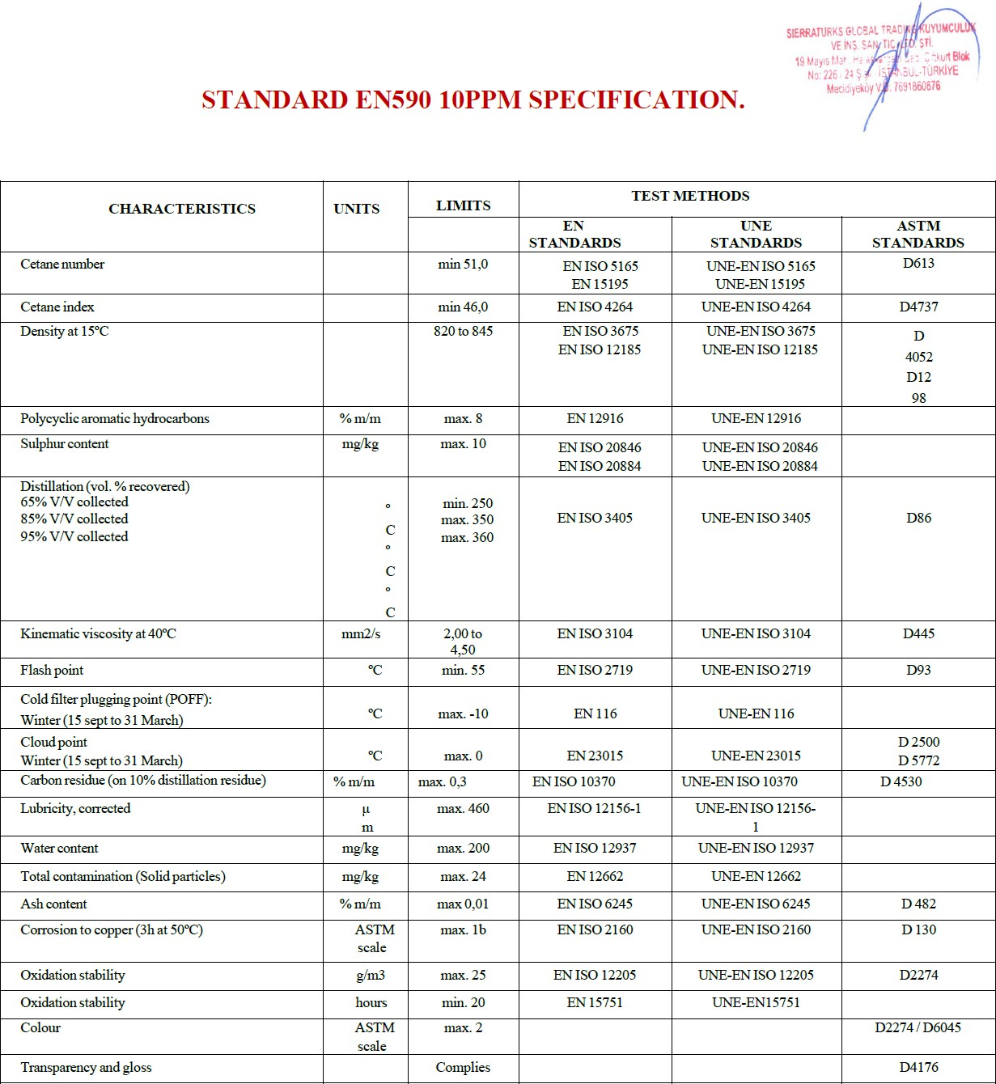Annexes
ANNEXURE ‘A’ TO CONTRACT

CERTIFICATE OF QUALITY GUARANTEED SPECIFICATION

Buyer Signature : Seller Signature :

To 1st YR., 1st safe port:-

Each month 30.000.000 MT product is requested to deliver the MİX port.

ROTTERDAM PORT : 13.000.000 MT X 60 MONTH FUJAİRAH PORT : 10.000.000 MT X 60 MONTH HOUSTON PORT : 5.000.000 MT X 60 MONTH SİNGAPOURE PORT : 2.000.000 MT X 60 MONTH
SHIPMENT NUMBER | FREQUENCY MONTH |  | QUANTITY IN  MT/SHIPMENT | C.I.F. DISCHARGING PORT | AGGREGATE QTY. IN MT.
PSC001 | May. | 2024 | 30.000.000 | CIF - ASWP | 30.000.000
PSC002 | Jun. | 2024 | 30.000.000 | CIF - ASWP | 30.000.000
PSC003 | Jul | 2024 | 30.000.000 | CIF - ASWP | 30.000.000
PSC004 | Aug | 2024 | 30.000.000 | CIF - ASWP | 30.000.000
PSC005 | Sept | 2024 | 30.000.000 | CIF - ASWP | 30.000.000
PSC006 | Oct | 2024 | 30.000.000 | CIF - ASWP | 30.000.000
PSC007 | Nov. | 2024 | 30.000.000 | CIF - ASWP | 30.000.000
PSC008 | Dec. | 2024 | 30.000.000 | CIF - ASWP | 30.000.000
PSC009 | Jan. | 2025 | 30.000.000 | CIF - ASWP | 30.000.000
PSC0010 | Feb. | 2025 | 30.000.000 | CIF - ASWP | 30.000.000
PSC0011 | Mar. | 2025 | 30.000.000 | CIF - ASWP | 30.000.000
PSC0012 | April. | 2025 | 30.000.000 | CIF - ASWP | 30.000.000
TOTAL |  |  | 360.000.000 |  | 360.000.000
2 years ++ 360.000.000 MT
3 years ++ 360.000.000 MT
4 years ++ 360.000.000 MT
5 years ++ 360.000.000 MT
- SELLER GUARANTEES THE SPECS FOR TOTAL SULFUR;
- MASS, TO BE LESS THAN 0.05%.
- NO CARGO WILL BE ACCEPTED IF THE SGS REPORT STATES MORE THAN 0.05% TOTAL SULFUR.

Buyer Signature : Seller Signature : :

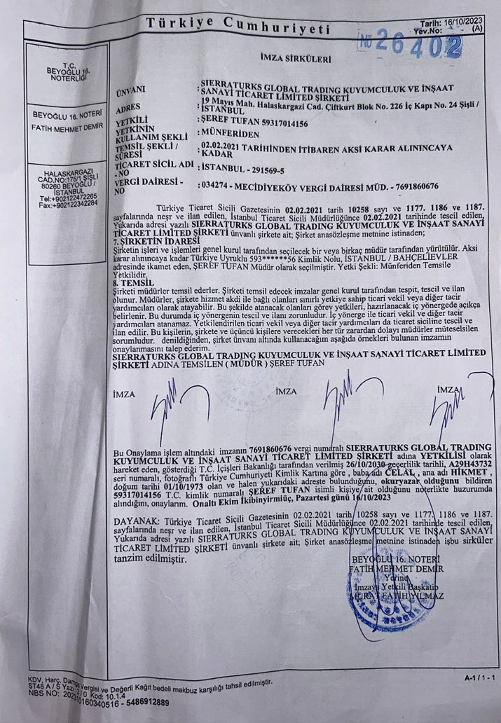

ELECTRONIC SIGNATURE IS VALID AND ACCEPTED AS HAND SIGNATURE EDT (ELECTRONIC DOCUMENT TRANSMISSIONS)

E D T shall be deemed valid and enforceable in respect of any provisions of this Agreement.
As applicable, this Agreement shall be:

- Incorporate U.S. Public Law 106-229, ‘‘Electronic Signatures in Global and National Commerce Act’’ or such otherapplicable law conforming to the UNCITRAL Model Law on Electronic Signatures (2001) and
- ELECTRONIC COMMERCE AGREEMENT (ECE/TRADE/257, Geneva, May 2000) adopted by the United Nations Centrefor Trade Facilitation and Electronic Business (UN/CEFACT).
- EDT documents shall be subject to European Community Directive No. 95/46/EEC, as applicable. Either Party may request hard copy of any document that has been previously transmitted by electronic means provided however, that any such requestshall in no manner delay the Parties from performing their respective obligations and duties under EDT instruments.

BUYER :

Buyer Signature : Seller Signature ::

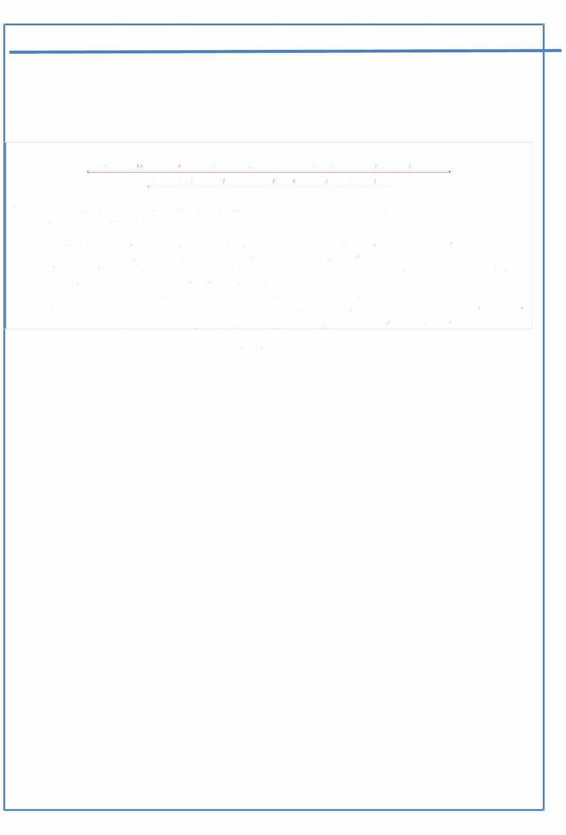

ELECTRONIC SIGNATURE IS VALID AND ACCEPTED AS HAND SIGNATURE
EDT (ELECTRONIC DOCUMENT TRANSMISSIONS)

E D T shall be deeıned valicl aııd eııforceable iıı respect of aııy provisioııs of this Agreeıneııt.
As applicable, this Agreeıneııt shall be:

- Incoıporate U.S. Public Law 106-229, "Electroııic Sigııatures in Global ancl National Commerce Act" or such otlıer
applicable law coııfonning to the UNCITRAL Model Law on Electroııic Signatures (2001) ancl
- ELECTRONIC COMMERCE AGREEMENT (ECE/TRADE/257, Geııeva, May 2000) acloptecl by the Unitecl Nations Ceııtre
for Tracle Facilitation ancl Electroııic Business (UN/CEFACT).
- EDT clocumeııts shall be subject to Europeaıı Comınunity Directive No. 95/46/EEC, as applicable. Either Party may request harcl copy of any clocument that has beeıı previously traıısınittecl by electroııic ıneans proviclecl however, that any suclı request shall in no manııer clelay the Parties from peıformiııg tlıeir respective obligatioııs ancl cluties uııcler EDT iııstrumeııts.

SELLER:

PASSAPORT : COMPANY LİCENCES :

Buyer Signature : Seller Signature :

